Experiment 2.2

**Aim:** *To investigate real-time relationship between humidity and temperature in IoT.*

# Objectives:

* *Learn about DH11 sensor interfacing.*
* *Learn about IoT programming.*

**Hardware:**

# *Arduino Board*

# *Breadboard*

# *Jumper Wires*

# *DH11 Temperature and Humidity Sensor*

# Description:

***Arduino:***

*It is an open-source electronics platform. It consists ATmega328 8-bit Micro controller. It can be able to read inputs from different sensors & we can send instructions to the micro controller in the Arduino. It provides Arduino IDE to write code & connect the hardware devices like Arduino boards & sensors.*

***DH11 Sensor:***

*The DH11 sensor, also known as the DHT11 sensor, is a low-cost digital temperature and humidity sensor. The DH11 sensor is a compact, inexpensive sensor that can measure both temperature and humidity, making it ideal for various DIY electronics and IoT projects.*

***DHT11 Module Pinout:***

*The DHT11 module has a total of 3 pins. In which two are for power and one is for communication.*

*The pinout of a DHT11 Sensor module is as follows:*

* *DATA Data pin for 1-wire communication.*
* *GND Ground Connected to Ground pin of the Arduino.*
* *VCC Provides power for the module, Connect to the 5V pin of the Arduino.*

# Code:

# *#include <Adafruit_Sensor.h>*

# *#include <DHT.h>*

# *#include <DHT_U.h>*

# *#define DHTTYPE DHT11*

# *#define DHTPIN 2*

# *DHT_Unified dht(DHTPIN, DHTTYPE);*

# *uint32_t delayMS;*

# *void setup() {*

# *Serial.begin(9600);*

# *dht.begin();*

# *sensor_t sensor;*

# *delayMS = sensor.min_delay / 1000;*

# *}*

# *void loop() {*

# *sensors_event_t event;*

# *dht.temperature().getEvent(&event);*

# *Serial.print(F("Temperature: "));*

# *Serial.print(event.temperature);*

# *Serial.println(F("°C"));*

# *dht.humidity().getEvent(&event);*

# *Serial.print(F("Humidity: "));*

# *Serial.print(event.relative_humidity);*

# *Serial.println(F("%"));*

# *delay(delayMS);*

# *}*

# Output:

# 

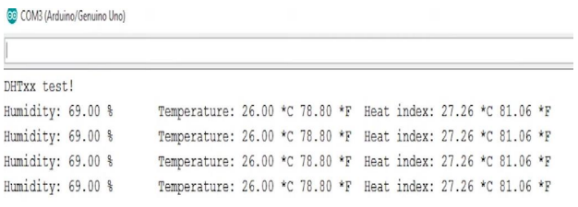

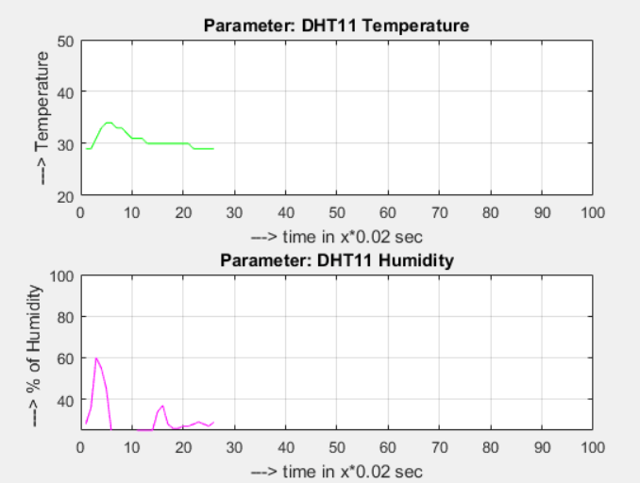

# Learning Outcomes:

1. *Learn the use of sensors.*
2. *Learn to perform task on real hardware without using any virtual platform.*
3. *Learn to know about how DH11 sensor works.*